Problem Statement 2: Shopping Cart for a Bookstore–Database schema design.

Database name : Shopping cart

create database shoppingcart;

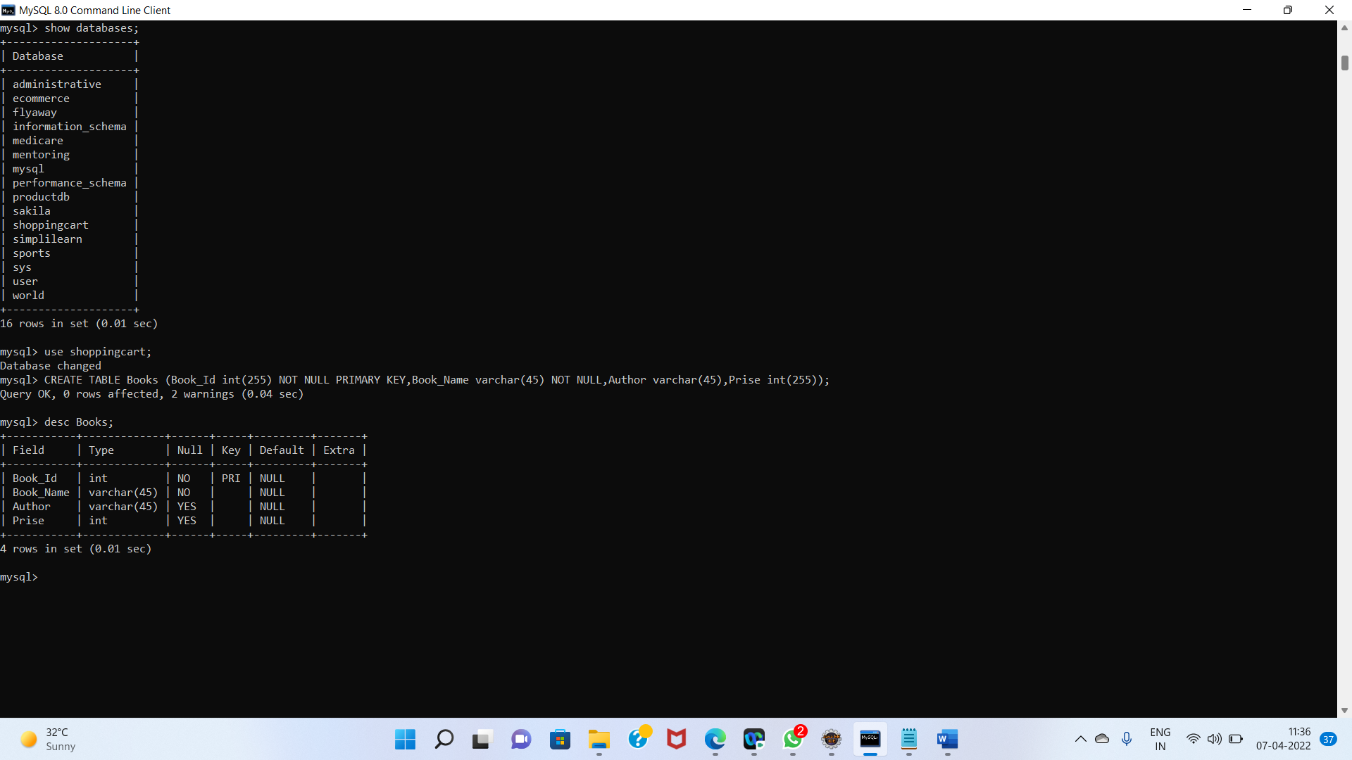

Design of the table

1)Books

Code : CREATE TABLE Books (Book_Id int(255) NOT NULL PRIMARY KEY,Book_Name varchar(45) NOT NULL,Author varchar(45),Prise int(255));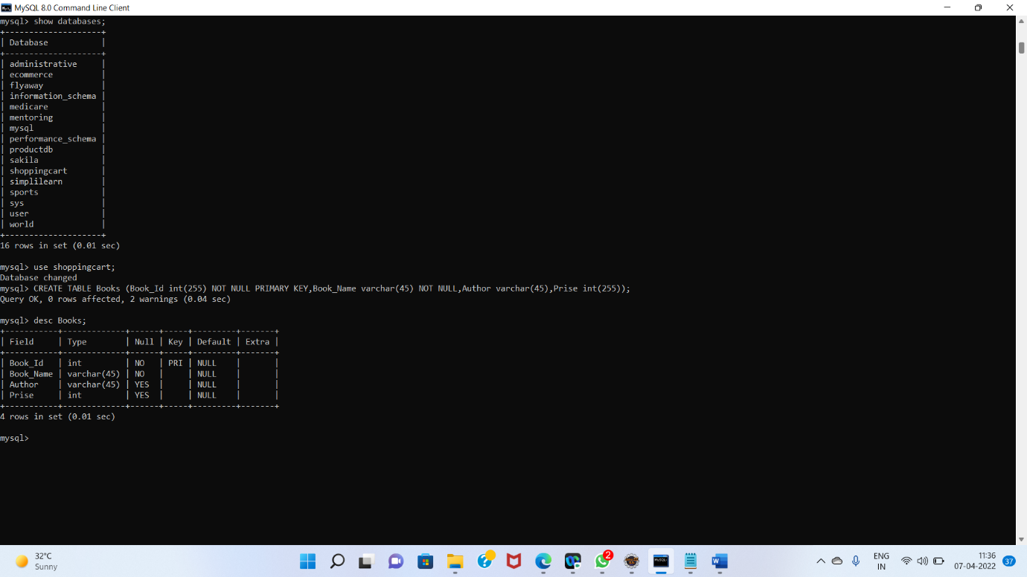

2) Order_Details (Order_Id, Book _Id, Cust_ Name, Phone_ No, Address, Order _Date, Quantity)

Code: CREATE TABLE Order_Details (Order_Id INT(255) NOT NULL PRIMARY KEY,Book_Id varchar(45) NOT NULL, Cust_Name varchar(45) NOT NULL,Phone_No varchar(45),Address varchar(45),Order_Date varchar(45),Quantity varchar(45));

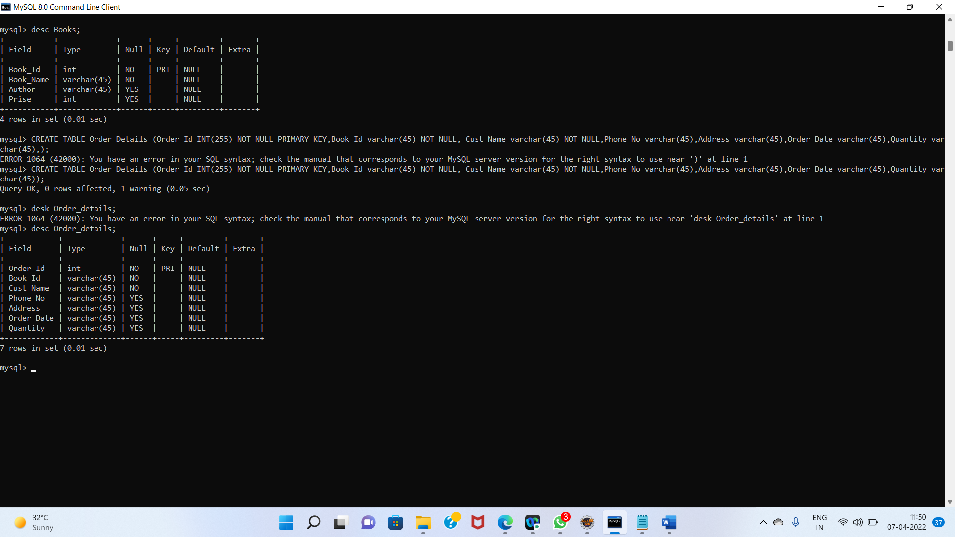

3) Users (first_name, address, email, user_name, password, registration_date)

Code: CREATE TABLE users (first_name varchar(255) NOT NULL PRIMARY KEY,address varchar(45) NOT NULL, email varchar(45) NOT NULL,user_name varchar(45),password varchar(45),registration_date varchar(45));

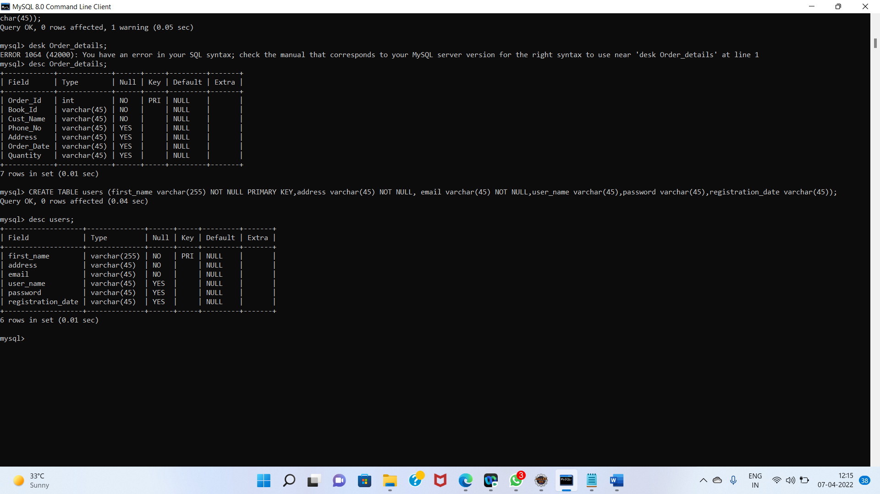

Datebase are created

